

**The Superior University, Lahore**



**TASK 4 (FALL 2024)**

|  |  |  |  |  |  |  |  |  |
| --- | --- | --- | --- | --- | --- | --- | --- | --- |
| Course Title: | PAI | | | | Course Code: | CPR601260 | Credit Hours: | 4 |
| Instructor: | SIR RASIKH ALI | | | | Program Name: | BSAI | | |
| Semester: | 4th | Batch: | F23 | Section: | BSAIM-4C | Date: | 6 March, 2025 | |
| Time Allowed: |  | | | | Maximum Marks: | |  | |
| Student’s Name: | ZAID MEHMOOD | | | | Reg. No. | SU92-BSAIM-F23-128 | | |
| Lab4-Task | | | | | | | | |

**LAB 4 TASK:-**

***N-Queens Problem Dynamic***

**Code:-**

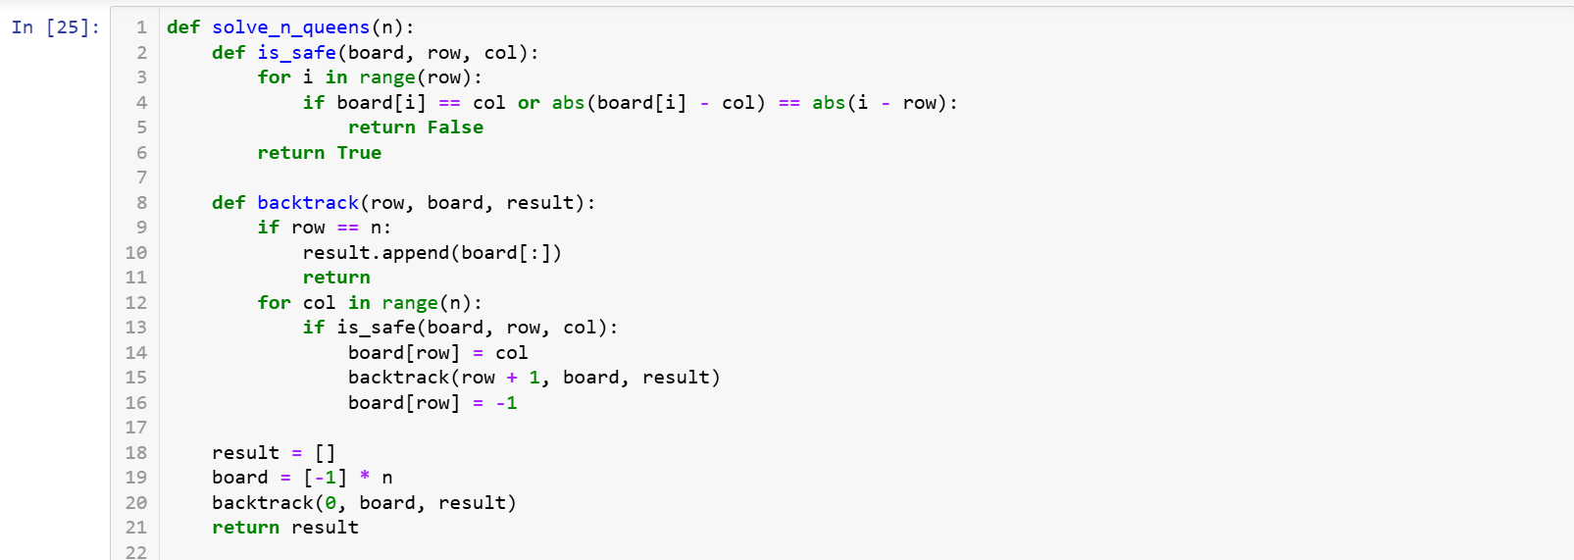 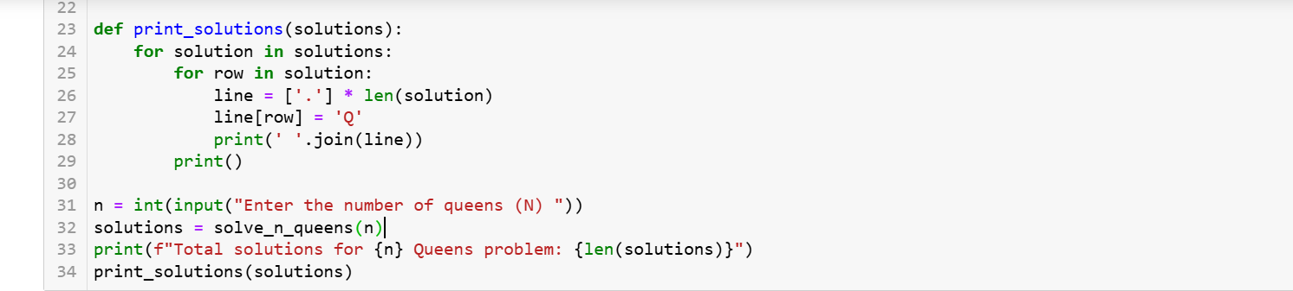

1. **is_safe Function:**
   * **Checks if placing a queen at (row, col) is safe.**
   * **Ensures no two queens are in the same column or diagonal.**
2. **backtrack Function:**
   * **Recursively tries to place queen row by row.**
   * **If a valid configuration is found, it is added to the result list.**
   * **If a placement leads to a conflict, it backtracks and tries the next position.**
3. **print_solutions Function:**
   * **Prints the chessboard for each valid configuration.**

**Output:**



